SWE20004 Technical Software Development Semester 1 2020

Assignment 3 report

Name: Dipesh Goyal Student ID:102558284

Lab class: Friday,12:30 Tutor: Srikanth Thudmu

Due Date: Monday 25th May 2020

Date Submitted: Monday, 18 May 2020

Assignment Title: Student Data Management

Problem 1

Program description
This program reads data from a file and the prints it in a formatted manner. The program can also perform various functions such as searching, sorting , find the highest average mark and adding records to the data. This is achieved by using arrays of structure.

Inputs and Outputs
The inputs and outputs for this program are described in Table 1.

Table 1. Data dictionary:
Data to be stored | Sample data | Type of data | C++ type | Input method | In /  Out | Variable name
Student Records from file | Zen  1101825  Computer  4  88  98  52  95 | student_tag | User-defined structure | Read_file function.  Reading from file into array with function | cout | student_array
1 or 0  To indicate whether the data is sorted or not | 1 | number | Integer | Value of count is assigned to var.  (count is passed into function with address) | cin | var
Name Student | Zen | Letters | String | cin | in | name
Filename | Students.txt | Characters | String | Initialized | in | filename
User menu choice | 1 | character | char | cin | in | c
Linear = 1, Binary = 2 | 1 | character | char | cin | in | choice
Sort  Name =1  Marks = 2 | 1 | character | char | cin | in | choice
Max  Average marks | 56.50 | numbers | double | Using if statement and loop to find largest value | in | max

Source code: (No pseudo code needed)
- #include <iostream>
- #include <string>
- #include <fstream>
- #include <iomanip>

- using namespace std;

- //Structures
- typedef struct
- {
- string name;
- string id;
- } person_tag;

- typedef struct
- {
- string course_name;
- int no_of_units;
- int marks[4];
- double avg;
- } course_tag;

- typedef struct
- {
- person_tag student_info;
- course_tag course_info;
- } student_tag;

- //function protypes
- char menu();
- int read_file(student_tag *s, int *array_size);
- void display_students(student_tag *s, int array_size);
- void sort_mark(student_tag *s, int array_size);
- void sort_name(student_tag *s, int array_size);
- void sort_details(student_tag *s, int array_size, int *count);
- int binary_search(student_tag *s, string name, int array_size);
- int linear_search(student_tag *s, string name, int array_size);
- void search_student(student_tag *s, int array_size, string name, int count);
- void find_maximum(student_tag *s, int array_size);
- void update_file();

- int main()
- {
- student_tag student_array[100]; //array of size 100 of datatype student_tag
- int array_size = 0;
- int var = 0;
- string name;
- int count = 0;
- char c; //switch statement to display menu
- do
- {
- c = menu(); // MENU function displays option and returns user input
- switch (c) //c is storing the user input for choice
- {
- case '1':
- read_file(student_array, &array_size); // reads the file
- display_students(student_array, array_size); // displays the file contents
- break;
- case '2':
- //Sorting
- read_file(student_array, &array_size);
- sort_details(student_array, array_size, &count);
- display_students(student_array, array_size);
- break;
- case '3':
- //Searching
- cout << "------SEARCHING----------\n";
- cout << "Input name: ";
- cin >> name;
- read_file(student_array, &array_size);
- var = count;
- search_student(student_array, array_size, name, var);
- break;
- case '4':
- //Find Max Average
- cout << "\n-------DETAILS OF STUDENT WHO GOT MAXIMUM AVERAGE MARK--------\n";
- read_file(student_array, &array_size);
- find_maximum(student_array, array_size);
- break;
- case '5':
- //Update File
- read_file(student_array, &array_size);
- update_file();
- read_file(student_array, &array_size);
- break;
- case '6':
- printf("SEE YOU LATER! \n");
- exit(1);
- break;
- default:
- cout << "Please try again! Your input is invalid!\n";
- break;
- }
- } while (c != 6); //while loop keeps running till 4 is chosen as an option.
- }

- char menu()
- {
- //displays options
- char c;
- cout << "\n----MENU----\n";
- cout << "1.Display student's details\n";
- cout << "2.Sort the student's details\n";
- cout << "3.Search for a particular student's mark\n";
- cout << "4.Find the details of student who received maximum average\n";
- cout << "5.Add new student to the record\n";
- cout << "6.Quit program\n";
- cout << "Your choice: ";
- cin >> c;
- return c; // returns input for the switch
- }

- int read_file(student_tag *s, int *array_size) //readfile function
- {
- int count;
- double total = 0;
- string filename = "students.txt"; // filename
- ifstream inFile;

- inFile.open(filename.c_str());

- if (inFile.fail()) // if file doesnt open successfully
- {
- cout << "The File was not opened successfully\n";
- cout << "Please check that the file currently exists\n";
- return 0;
- }
- int i = 0;
- while (inFile.peek() != EOF) // until the end of the file
- {
- double total = 0;
- inFile >> s[i].student_info.name;
- inFile >> s[i].student_info.id;
- inFile >> s[i].course_info.course_name;
- inFile >> s[i].course_info.no_of_units;
- for (int j = 0; j < s[i].course_info.no_of_units; j++)
- {
- inFile >> s[i].course_info.marks[j];
- total = total + s[i].course_info.marks[j];
- }
- s[i].course_info.avg = total / s[i].course_info.no_of_units; //storing average
- i++;
- }
- *array_size = i; // temp has the same value of i to check how many records of data is in the file
- inFile.close(); //close file
- }

- void display_students(student_tag *s, int array_size) //display function
- {
- int i;
- cout << "-----STUDENTS' LIST-----\n\n";
- for (i = 0; i < array_size - 1; i++)
- { //loop runs till the count is same as the value of temp, which is the end of the file.
- double total = 0;
- cout << "---------------------------\n";
- cout << "Name: " << s[i].student_info.name << "\n";
- cout << "ID: " << s[i].student_info.id << "\n";
- cout << "Course Name: " << s[i].course_info.course_name << "\n";
- cout << "Number of units: " << s[i].course_info.no_of_units << "\n";
- for (int j = 0; j < s[i].course_info.no_of_units; j++)
- {
- cout << s[i].course_info.marks[j] << "\n";
- }
- cout << "Average : " << setprecision(2) << fixed << s[i].course_info.avg << "\n";
- cout << "------------------------\n\n";
- }
- }

- void sort_mark(student_tag *s, int array_size)// sorting by marks
- {
- for (int key = 0; key < array_size - 1; key++)
- {
- for (int i = 0; i < array_size - 1; i++)
- {
- if (s[i].course_info.avg > s[key].course_info.avg)
- {
- std::swap(s[key], s[i]);
- }
- }
- }
- }

- void sort_name(student_tag *s, int array_size) // sorting by name
- {
- for (int i = 0; i < array_size - 1; i++)
- {
- for (int m = i + 1; m < array_size - 1; m++)
- {
- if ((s[i].student_info.name) > (s[m].student_info.name))
- {
- std::swap(s[i], s[m]);
- }
- }
- }
- }

- void sort_details(student_tag *s, int array_size, int *count)
- {
- int invalid = 0;
- char choice;
- int i = 0;

- cout << "------SORTING--------\n";
- do
- {
- invalid = 0;
- cout << "1.Sort by name\n";
- cout << "2.Sort by average mark\n";
- cout << "Input choice: ";
- cin >> choice;
- if (choice == '1')
- {
- *count = 1; // for the binary search to know the data is sorted before using binary
- cout << "sort by name\n";
- sort_name(s, array_size);
- cout << "\n------SORTING FINISHED----------\n\n";
- cout << "Array after sorting by name :\n\n";
- }
- else if (choice == '2')
- {
- *count = 1; // for the binary search to know the data is sorted before using binary
- sort_mark(s, array_size);
- cout << "\n------SORTING FINISHED----------\n\n";
- cout << "Array after sorting by average marks :\n\n";
- }
- else
- {
- cout << "Please try again! Your input is invalid!\n\n";
- invalid = 1;
- }
- } while (invalid == 1);
- }

- int linear_search(student_tag *s, string name, int array_size) // linear search
- {
- int i;
- for (i = 0; i < array_size; i++){
- if (s[i].student_info.name == name)
- {
- return i;
- }
- }
- return -1;
- }

- int binary_search(student_tag *s, string name, int array_size)
- {
- int low = 0;
- int high = array_size - 1;
- int middle; //variable for storing middle value
- //while loop continue until low subscript is greater then higher
- while (low <= high)
- {
- middle = (low + high) / 2; //determines middle element
- //if search query is same as middle element, return middle
- if (name == s[middle].student_info.name)
- {
- return middle;
- //if search is less than middle, set new high
- }
- else if (name < s[middle].student_info.name)
- high = middle - 1; //search lowest end of the array
- //if search query is greater than middle, set new low
- else
- low = middle + 1;
- }
- return -1;
- }

- void search_student(student_tag *s, int array_size, string name, int count)
- {
- // search student
- char choice;
- int i = 0;
- int index1 = 0;
- int index = 0;
- int invalid = 0;
- char temp;
- do
- {
- invalid = 0;
- cout << "1.Linear Search\n";
- cout << "2.Binary Search\n";
- cout << "Input choice: ";
- cin >> choice;
- if (choice == '1') // Linear
- {
- index1 = linear_search(s, name, array_size);
- ///cout << "LINEAR SEARCH KEY: " << s[index1].student_info.name << "\n";
- if(index1 != -1 ){
- cout << "\n\nName: " << s[index1].student_info.name << "\n";
- cout << "ID: " << s[index1].student_info.id << "\n";
- cout << "Course Name: " << s[index1].course_info.course_name << "\n";
- cout << "Number of units: " << s[index1].course_info.no_of_units << "\n";
- for (int j = 0; j < s[index1].course_info.no_of_units; j++)
- {
- cout << s[index1].course_info.marks[j] << "\n";
- }
- cout << "Average : " << setprecision(2) << fixed << s[index1].course_info.avg << "\n";
- cout << "------------------------\n\n";
- cout << "-----> SEARCHING FINISHED!!!!\n\n";
- }else{
- cout << "Student with name " << name << " is not in the list\n\n";
- cout << "-----> SEARCHING FINISHED!!!!\n\n";
- }
- }
- else if (choice == '2' && count != 1) // count is to check if data is sorted or not
- {
- cout << "Can't perform binary search on unsorted array!!!\n\n";
- cout << "-----> SEARCHING FINISHED!!!!\n\n";
- }
- else if (choice == '2' && count == 1)
- {
- sort_mark(s, array_size);
- index = binary_search(s, name, array_size);
- if(index == -1){
- cout << "Student with name " << name << " is not in the list\n\n";
- cout << "-----> SEARCHING FINISHED!!!!\n\n";
- }else{
- cout << "\n\nName: " << s[index].student_info.name << "\n";
- cout << "ID: " << s[index].student_info.id << "\n";
- cout << "Course Name: " << s[index].course_info.course_name << "\n";
- cout << "Number of units: " << s[index].course_info.no_of_units << "\n";
- for (int j = 0; j < s[index].course_info.no_of_units; j++)
- {
- cout << s[index].course_info.marks[j] << "\n";
- }
- cout << "Average : " << setprecision(2) << fixed << s[index].course_info.avg << "\n";
- cout << "------------------------\n\n";
- cout << "-----> SEARCHING FINISHED!!!!\n\n";
- }
- }
- else
- {
- cout << "Please try again! Your input is invalid!\n\n";
- invalid = 1;
- }
- } while (invalid == 1);
- }

- void find_maximum(student_tag *s, int array_size) //display function
- {
- double max = 0;
- int i = 0;
- for (i = 0; i < array_size - 1; i++)
- {
- if (s[i].course_info.avg > max)
- max = s[i].course_info.avg; // getting max
- }
- for (i = 0; i < array_size; i++)
- if (s[i].course_info.avg == max) // Checking for max
- {
- cout << "\nName: " << s[i].student_info.name << "\n";
- cout << "ID: " << s[i].student_info.id << "\n";
- cout << "Course Name: " << s[i].course_info.course_name << "\n";
- cout << "Number of units: " << s[i].course_info.no_of_units << "\n";
- for (int j = 0; j < s[i].course_info.no_of_units; j++)
- {
- cout << s[i].course_info.marks[j] << "\n";
- }
- cout << "Average : " << setprecision(2) << fixed << s[i].course_info.avg << "\n";
- cout << "------------------------\n\n";
- }
- }

- void update_file() //update function
- {
- // adding to file
- ofstream outFile;
- student_tag s;
- outFile.open("students.txt", ios::app);
- cout << "-----UPDATE DATA-----\n\n";
- cout << "Enter name: ";
- cin >> s.student_info.name;
- outFile << s.student_info.name << "\n";
- cout << "Enter ID: ";
- cin >> s.student_info.id;
- outFile << s.student_info.id << "\n";
- cout << "Enter course name: ";
- cin >> s.course_info.course_name;
- outFile << s.course_info.course_name << "\n";
- cout << "Enter number of units: ";
- cin >> s.course_info.no_of_units;
- outFile << s.course_info.no_of_units << "\n";
- cout << "Enter " << s.course_info.no_of_units << " marks: \n";
- for (int j = 0; j < s.course_info.no_of_units; j++)
- {
- cin >> s.course_info.marks[j];
- outFile << s.course_info.marks[j] << "\n";
- }

- cout << "\n\n-----> UPDATE FINISHED!!!!\n\n";
- outFile.close(); //close file
- }

Screenshots showing working program (Show all possible outcome)

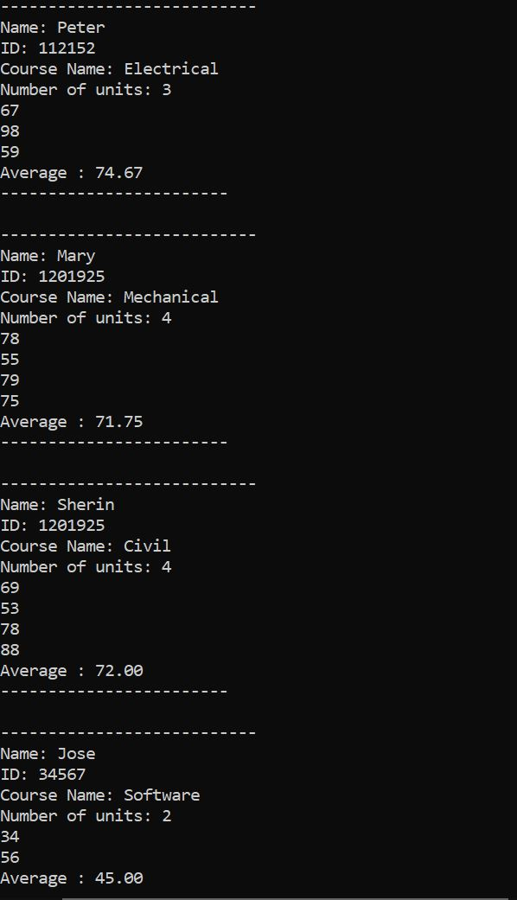

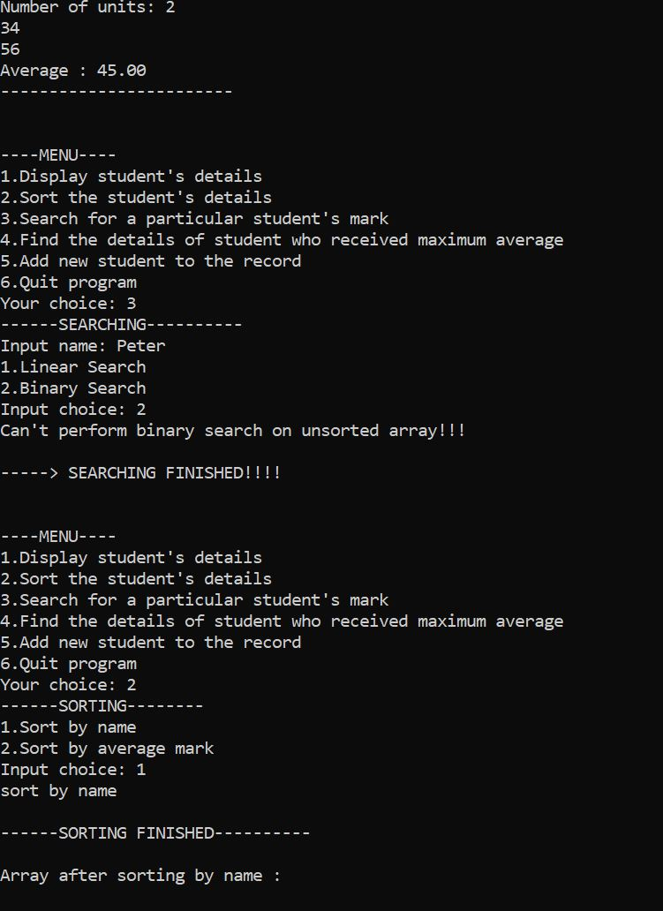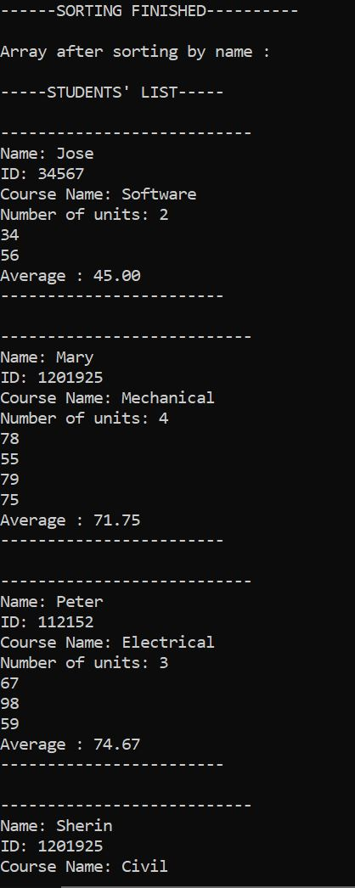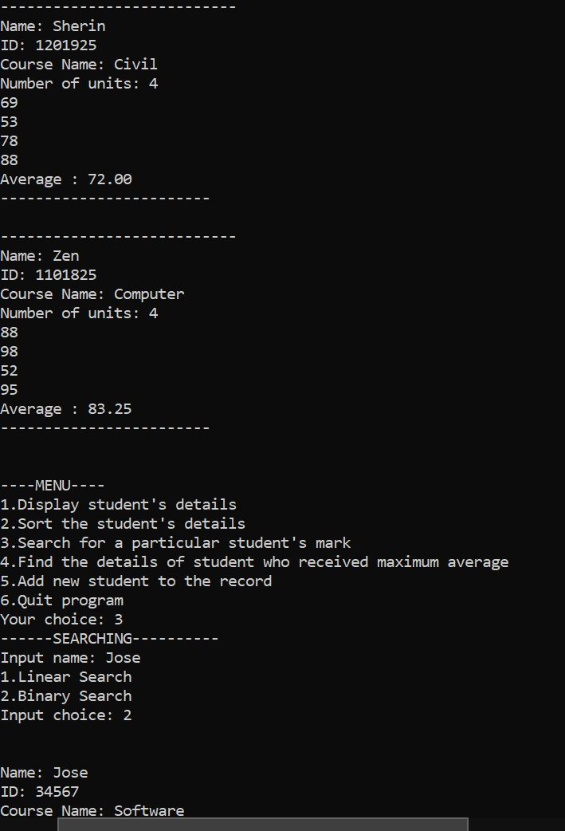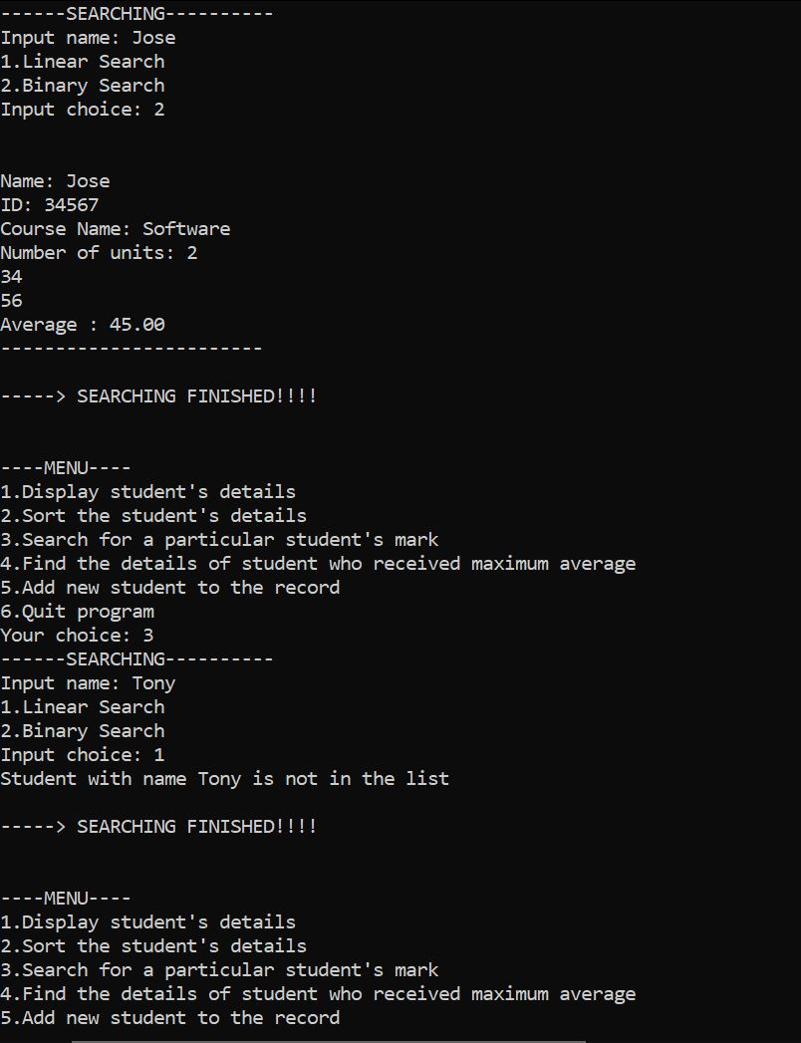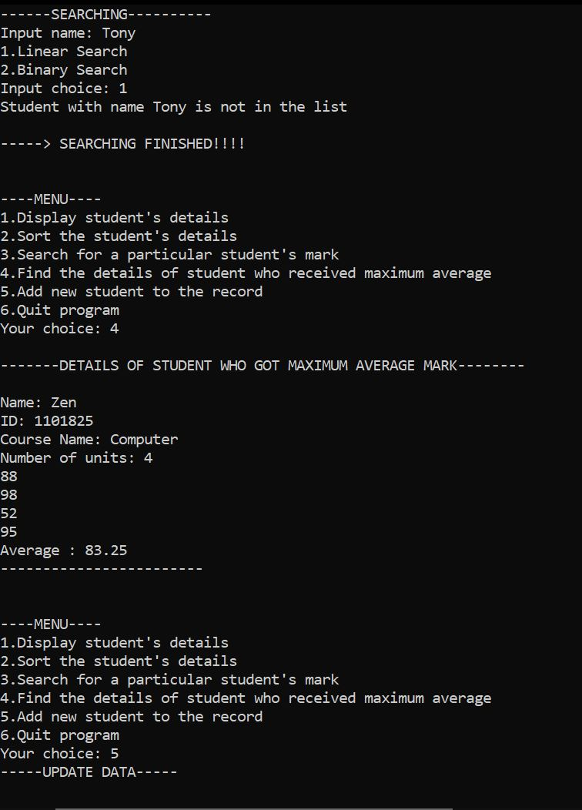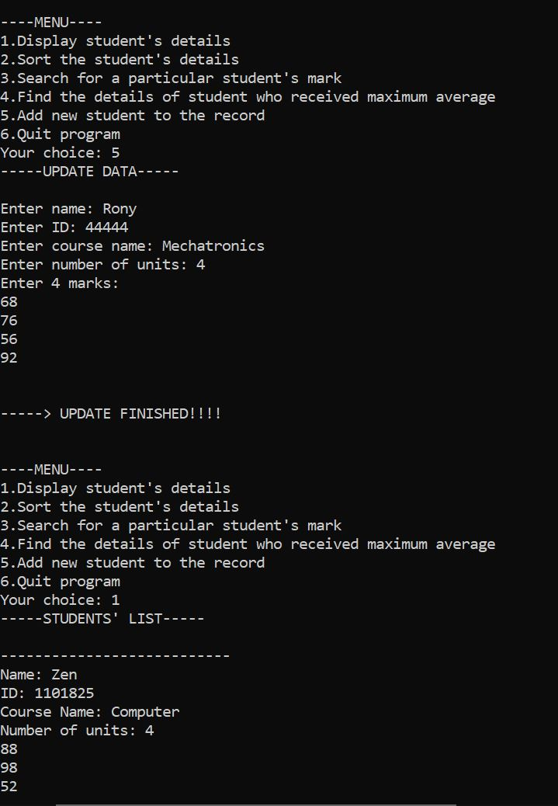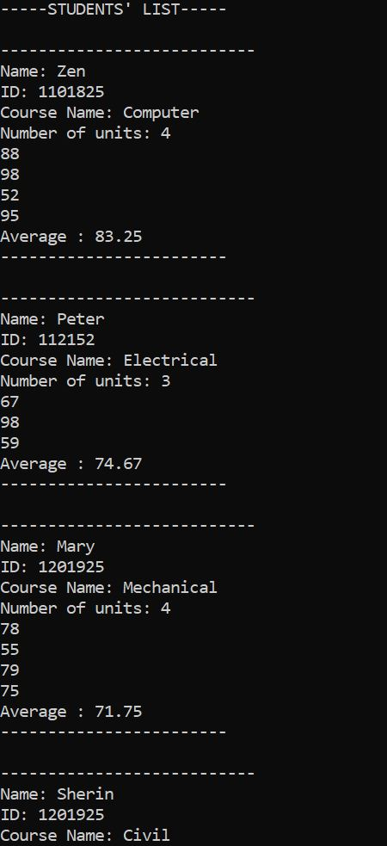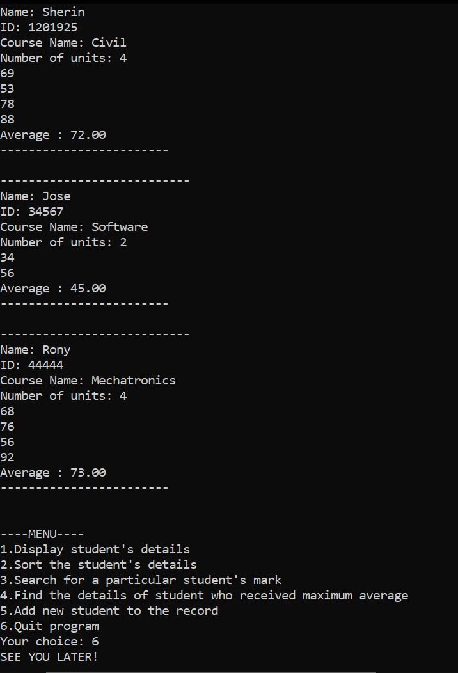

Problem 2

Program description
This program reads data from a file and the prints it in a formatted manner. The program can also perform functions such as searching and finding the highest average mark. This is achieved by using linked list.

Inputs and Outputs
The inputs and outputs for this program are described in Table 1.

Table 1. Data dictionary:
Data to be stored | Sample data | Type of data | C++ type | Input method | In /  Out | Variable name
Max  Average marks | 56.50 | numbers | double | Using if statement and loop to find largest value | in | max
Name Student | Zen | Letters | String | cin | in | name
Filename | Students.txt | Characters | String | Initialized | in | filename
User menu choice | 1 | character | char | cin | in | c

Source code: (No pseudo code needed)
- #include <iostream>
- #include <string>
- #include <fstream>
- #include <iomanip>

- using namespace std;

- struct person_tag
- {
- string name;
- string id;
- };

- struct course_tag
- {
- string course_name;
- int no_of_units;
- int marks[4];
- double avg;
- };

- struct student_tag
- {
- person_tag student_info;
- course_tag course_info;
- student_tag *next;
- };
- //self referential structure
- typedef struct student_tag Student_Tag;
- typedef Student_Tag *Student_TagPtr;

- Student_TagPtr hptr; //headptr
- Student_TagPtr cptr; // currentptr
- Student_TagPtr nptr;

- //function protypes
- void menu();
- void read_file();
- void display_students();
- void linear_search(string name);
- void find_maximum();

- int main()
- {
- string name;
- char c; //switch statement to display menu
- do
- {
- menu();
- cout << "Your choice: ";
- cin >> c;
- switch (c) //c is storing the user input for choice
- {
- case '1':
- //display
- read_file(); // reads the file
- display_students(); // displays the file contents
- break;
- case '2':
- //search
- cout << "Input name: ";
- cin >> name;
- cout << "----------SEARCHING----------\n";
- linear_search(name);
- break;
- case '3':
- //max average
- find_maximum();
- break;
- case '4':
- printf("SEE YOU LATER! \n");
- exit(1);
- break;
- default:
- cout << "Please try again! Your input is invalid!\n";
- break;
- }
- } while (c != 4); //while loop keeps running till 4 is chosen as an option.
- }

- void menu()
- {
- char c;
- cout << "\n----MENU----\n";
- cout << "1.Display student's details\n";
- cout << "2.Search for a student's mark\n";
- cout << "3.Find the details of student with largest average\n";
- cout << "4.Quit program\n\n";
- }

- void read_file() //readfile function
- {
- double total;
- hptr = nptr = NULL; //intialized to null
- string filename = "students.txt";
- ifstream inFile(filename);

- if (inFile.fail()) // if file doesnt open successfully
- {
- cout << "The File was not opened successfully\n";
- cout << "Please check that the file currently exists\n";
- exit(1);
- }
- while (inFile.peek() != EOF) // until the end of the file
- {
- total = 0;
- cptr = new Student_Tag;
- // Read the data into the node
- inFile >> cptr->student_info.name;
- inFile >> cptr->student_info.id;
- inFile >> cptr->course_info.course_name;
- inFile >> cptr->course_info.no_of_units;
- for (int j = 0; j < cptr->course_info.no_of_units; j++)
- {
- inFile >> cptr->course_info.marks[j];
- total = total + cptr->course_info.marks[j];
- }
- double average = total / cptr->course_info.no_of_units;
- cptr->course_info.avg = average; //storing average
- if (hptr == NULL)
- {
- // First item in the list. hptr pointing to first item
- hptr = cptr;
- }
- else
- {
- // if tot the first item, appending it to the tail.
- nptr->next = cptr;
- }
- nptr = cptr; // Move the tail pointer
- }
- cptr->next = NULL; // last items next pointer set to NULL
- inFile.close(); //close file
- }

- void display_students()
- {
- Student_TagPtr ptr;
- ptr = hptr;
- while (ptr != NULL)
- {
- cout << "The Student Name: " << ptr->student_info.name << " \n";
- cout << "The Student ID: " << ptr->student_info.id << " \n";
- cout << "The course name: " << ptr->course_info.course_name << " \n";
- cout << "Number of units " << ptr->course_info.no_of_units << " \n";
- cout << "Marks recieved: \n";
- for (int j = 0; j < ptr->course_info.no_of_units; j++)
- {
- cout << ptr->course_info.marks[j] << " \n";
- }
- cout << "Average : " << setprecision(2) << fixed << ptr->course_info.avg << " \n";
- cout << "------------------------\n\n";
- ptr = ptr->next;
- }
- }

- void linear_search(string name) // linear search
- {
- Student_TagPtr ptr;
- ptr = hptr;
- Student_TagPtr temp; // if name not found
- temp = hptr;
- int check = 0;
- //CHECKING IF NAME IS IN THE LIST
- while (temp != NULL)
- {
- if (temp->student_info.name != name){
- check=1;
- }
- temp = temp->next;
- }
- if(check==1){
- cout << "Student with name " << name << " is not in the list\n\n";
- }

- while (ptr != NULL)
- {
- if (ptr->student_info.name == name)
- {
- check = 0;
- cout << "The Student Name: " << ptr->student_info.name << " \n";
- cout << "The Student ID: " << ptr->student_info.id << " \n";
- cout << "The course name: " << ptr->course_info.course_name << " \n";
- cout << "Number of units " << ptr->course_info.no_of_units << " \n";
- cout << "Marks recieved: \n";
- for (int j = 0; j < ptr->course_info.no_of_units; j++)
- {
- cout << ptr->course_info.marks[j] << " \n";
- }
- cout << "Average : " << setprecision(2) << fixed << ptr->course_info.avg << " \n";
- cout << "------------------------\n\n";
- cout << "-----> SEARCHING FINISHED!!!!\n\n";
- }
- ptr = ptr->next;
- }
- }

- void find_maximum() //display function
- {
- cout << "\n-------DETAILS OF STUDENT WHO GOT MAXIMUM AVERAGE MARK--------\n";
- Student_TagPtr ptr;
- Student_TagPtr temp;
- ptr = hptr; // to get max
- temp =hptr; // to display largest average
- double max;

- while (ptr != NULL)
- {
- if (ptr->course_info.avg > max){
- max = ptr->course_info.avg; // getting max
- }
- ptr = ptr->next;
- }
- while (temp != NULL){
- if (temp->course_info.avg == max) // Checking for max
- {
- cout << "The Student Name: " << temp->student_info.name << " \n";
- cout << "The Student ID: " << temp->student_info.id << " \n";
- cout << "The course name: " << temp->course_info.course_name << " \n";
- cout << "Number of units " << temp->course_info.no_of_units << " \n";
- cout << "Marks recieved: \n";
- for (int j = 0; j < temp->course_info.no_of_units; j++)
- {
- cout << temp->course_info.marks[j] << " \n";
- }
- cout << "Average : " << setprecision(2) << fixed << temp->course_info.avg << " \n";
- cout << "------------------------\n\n";
- }
- temp = temp->next;
- }
- }

Screenshots showing working program (Show all possible outcome): 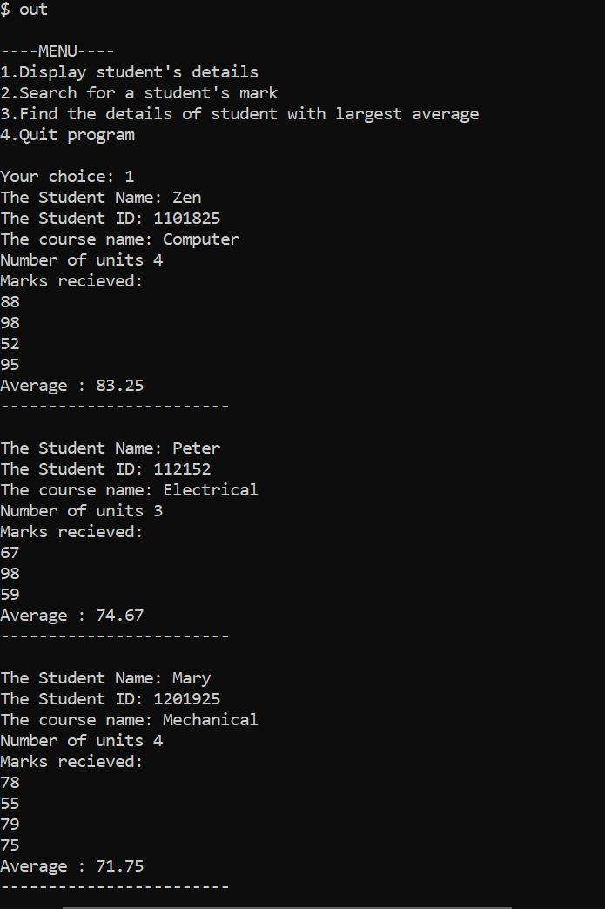
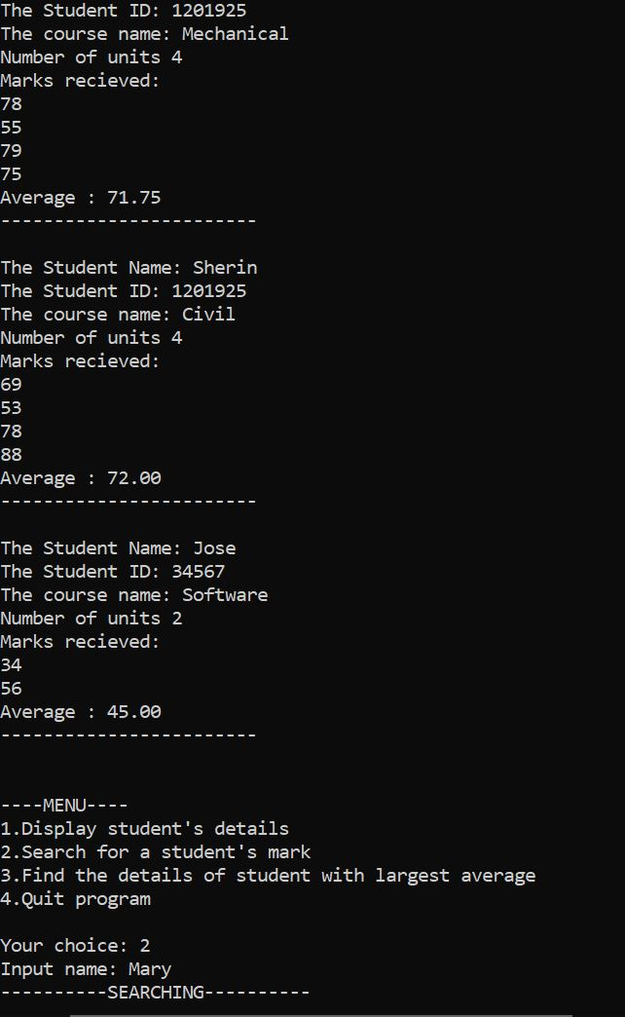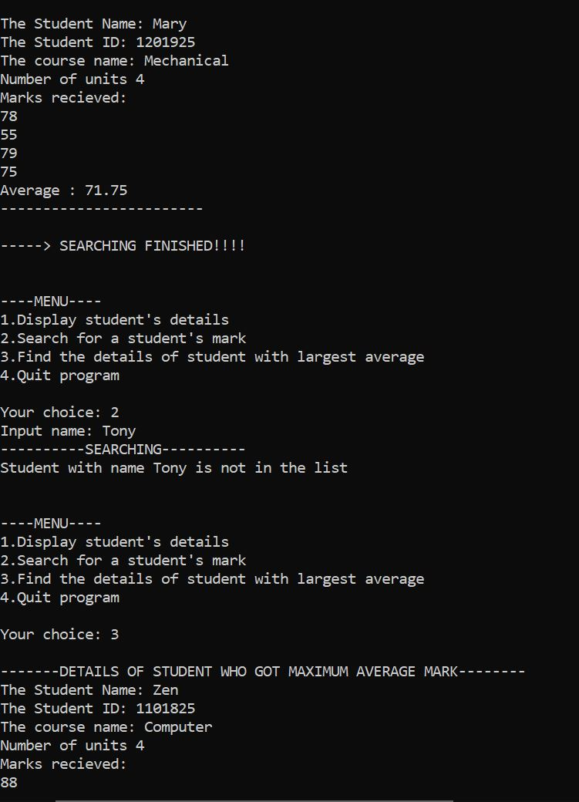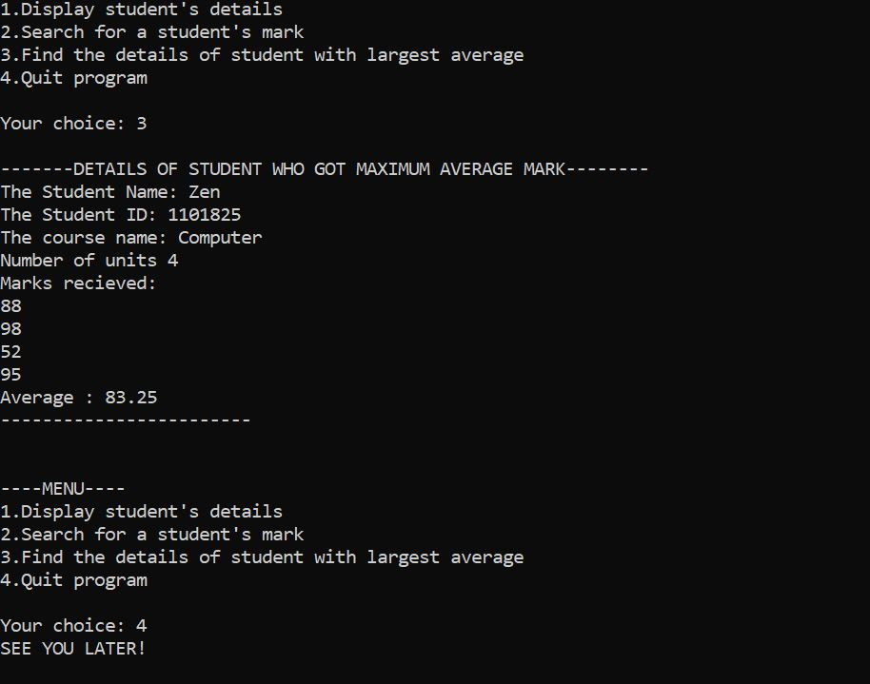

Task 8.5

Program description
This program sorts 3 integers using pointers. The user is asked to enter 3 integers. The integers are then passed into a function by address to be sorted. The function then uses if statements to sort the integers. Because they are being passed by address, their original values are automatically changed when displaying them again.

Source Code
- #include <iostream>

- using namespace std;

- //Function Prototype
- void reorder(int *a , int *b, int *c);

- int main()
- {
- int a;
- int b;
- int c;

- //Ask user to enter data
- cout << "Enter the value for A \n";
- cin >> a;
- cout << "Enter the value for B \n";
- cin >> b;
- cout << "Enter the value for C \n";
- cin >> c;

- // pass the address to function so it changes original values too.
- reorder(&a,&b,&c);
- //displaying results
- cout << "A: " << a << "\n";
- cout << "B: " << b << "\n";
- cout << "C: " << c << "\n";

- return 0;

- }

- //Function with pointers
- void reorder(int *a , int *b, int *c)
- {
- //if statements to order the integers
- int temp = 0;
- if(*a>*c)
- {
- temp=*c;
- *c=*a;
- *a=temp;
- }
- if(*a>*b)
- {
- temp=*b;
- *b=*a;
- *a=temp;
- }
- if(*b>*c)
- {
- temp=*c;
- *c=*b;
- *b=temp;
- }
- }

Screenshots showing working program
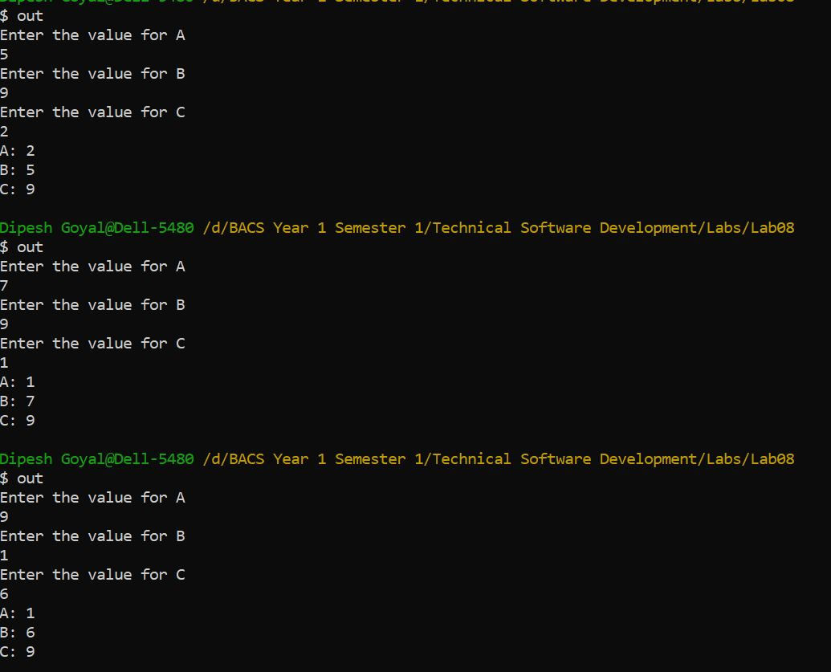

Task 8.6

Program description
This program calculates the voltage by multiplying the current and resistance. The program gets the current and resistance randomly from the range 1-10 and then they are passed into a function to be calculated. Pointers are used in the program.

Source Code
- #include <iostream>
- #include <iomanip>
- #include <time.h>

- using namespace std;

- //Function Protypes
- int calcVolts(int *current, int *resistance, int *voltage);
- void dispVolts(int *current, int *resistance, int *voltage);

- int main()
- {
- int current[10];
- int resistance[10];
- int voltage[10];
- srand(time(NULL));

- //gettings random numbers for current and resistance
- for(int i = 0; i < 10; ++i) {
- current[i] = rand() % 10 + 1;
- resistance[i] = rand() % 10 + 1;
- }

- calcVolts(current, resistance, voltage); // calculating voltage
- dispVolts(current, resistance, voltage); // displaying voltage

- return 0;
- }

- int calcVolts(int *current, int *resistance, int *voltage)
- {
- for (int i = 0; i < 10; i++)
- {
- voltage[i] = current[i] * resistance[i]; //mutiplying current with resistance to get voltage
- }
- }

- void dispVolts(int *current, int *resistance, int *voltage)
- {
- //displays results
- cout << "Current";
- cout << setw(15) << "Resistance";
- cout << setw(16) << "Voltage\n";
- for (int i = 0; i < 10; i++)
- {
- cout << current[i] << setw(15) << resistance[i] << setw(19) << voltage[i] << "\n";
- }
- }

Screenshots showing working program
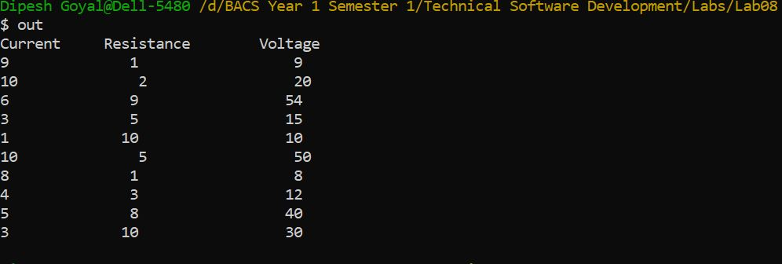

Task 9.2

Program description
This program utilizes structure to store employee data and then uses that data to perform certain actions such as searching salary of employee and company salary average.

Source Code

#include <string>
#include <iostream>

using namespace std;

//structures
typedef struct
{
string company_id;
string company_name;
}company_detail;

typedef struct
{
string emp_name;
string emp_id;
double salary;
company_detail cmp_detail;
}Emp;

//function prototypes
Emp get_data();
void print_data(Emp a[]);
double get_average( Emp a[], string y);
double get_salary( Emp y[],string x);

int main()
{
char menu;
Emp employee[5];
string name; // employee name
string cname; //company name
int i;
do { //switch menu
cout << "\n(1)Enter 1 to store employee data\n" <<
"(2)Enter 2 to print the employee details.\n" <<
"(3)Enter 3 to search for employee salary by name\n" <<
"(4)Enter 4 to calculate average salary of particular company\n" <<
"(5)Enter 5 to Exit.\n";
cin >> menu;
switch (menu)
{
case '1':
for (i = 0; i < 5; i++) // loop to store 5 records of employee
{
employee[i] = get_data();
}
break;
case '2':
print_data(employee); // prints all the data
break;
case '3':
cout << "\nEnter the employee name to search for salary: ";
cin >> name;
get_salary(employee,name); //gets salary for employee name entered
break;
case '4':
cout << "Enter the company name to get average salary: ";
cin >> cname;
cout << "The average salary for this company is " << get_average(employee,cname);
case '5':
return 0;
break;
default:
cout << "Error! Invalid Selection";
break;
}}while(menu != 5);
}
Emp get_data()
{
// gets employee data
Emp x;
company_detail y;
cout << "\nEnter Employee Details.." << endl;
cout << "Enter Employee ID.." << endl;
cin >> x.emp_id;
cout << "Enter Employee Name.." << endl;
cin >> x.emp_name;
cout << "Enter Company Details.." << endl;
cout << "Enter Company ID:.." << endl;
cin >> x.cmp_detail.company_id;
cout << "Enter Company Name:.." << endl;
cin >> x.cmp_detail.company_name;
cout << "Enter Employee Salary:.." << endl;
cin >> x.salary;
return x; //returns x which has a datatype of emp
}
void print_data(Emp a[])
{
// prints all data
int i;
for (i = 4; i >= 0; i--)
{
cout <<" \n *****Employee details*****" << endl;
cout <<"Employee ID: " << a[i].emp_id << endl;
cout <<"Employee Name: " << a[i].emp_name << endl;
cout <<"Employee Salary: " << a[i].salary<< endl;
cout <<"Company ID: " << a[i].cmp_detail.company_id << endl;
cout <<"Company Name: " << a[i].cmp_detail.company_name << endl;
}
}
double get_average( Emp a[], string y)
{
//gets averages
double sum = 0;
int i;
double temp = 0;
for (i = 0; i < 5; i++)
{
if (a[i].cmp_detail.company_name == y)
{
sum += a[i].salary;
temp++;
}
}
temp = sum / temp;
return temp;
}

double get_salary( Emp a[],string x)
{
int i;
for (i = 0; i < 5; i++)
{
if (a[i].emp_name == x)
{
cout << "The Salary of this employee is: $" << a[i].salary << endl;
return a[i].salary;
}
}
cout << "Employee not found\n";
}

Screenshots showing working program
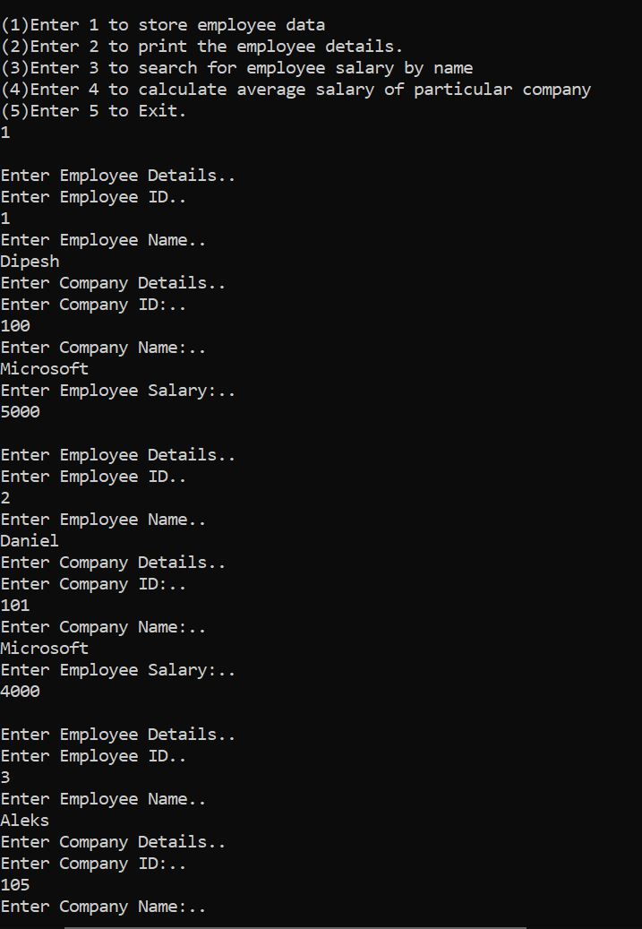
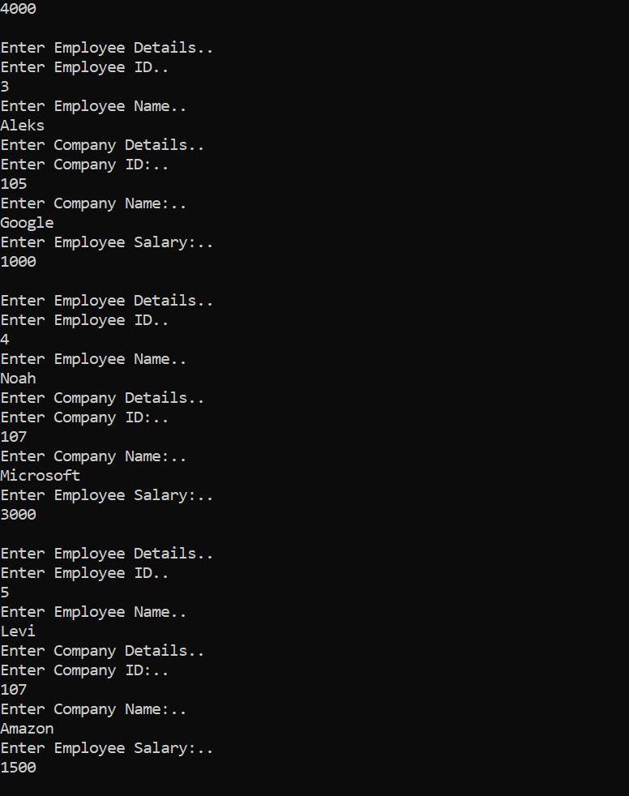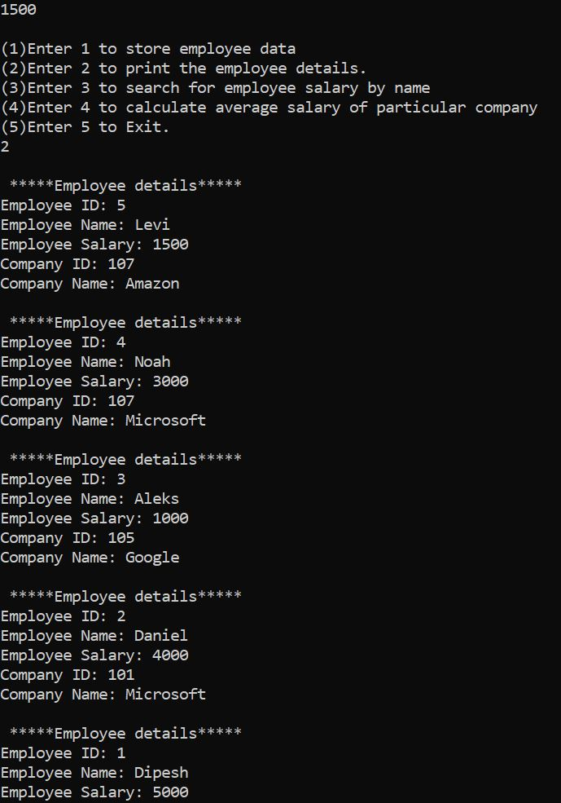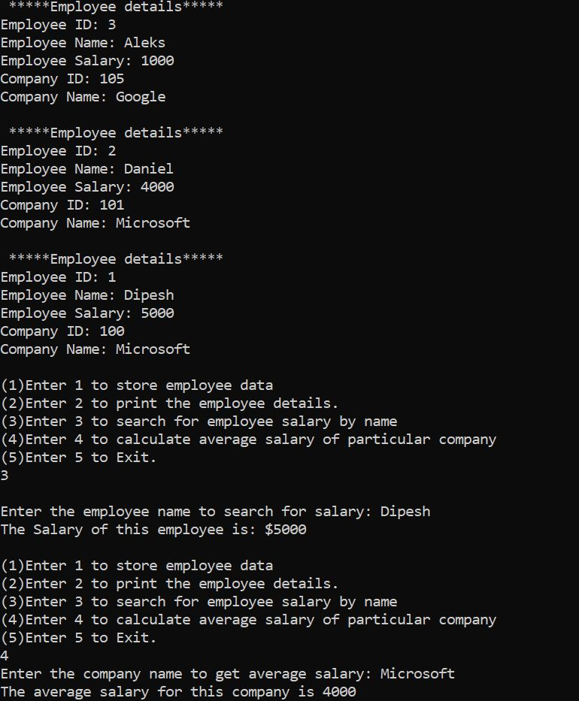

Task 9.3

Program description
This program uses vectors to store albums because the albums size is unknown. The user can enter multiple albums and then display them. The user can then select an album to play. If the album_name is found it will then open and play the entered track from the location entered by the user.

Source Code
- #include <iostream>
- #include <vector>

- using namespace std;

- enum genre{ Rock, Pop, Country}; // Enumeration

- //struct
- typedef struct
- {
- string album_name;
- genre kind;
- int track_number;
- string tracks[5];
- string tracklocation;
- }album;

- //Function prototypes
- int add_album(vector <album> &add);
- void print_all_album(vector <album> add);
- void select_track_to_play(vector <album>add, string album_name);

- int main()
- {
- string album_name;
- vector <album> albums;
- char menu;

- do { //switch menu
- cout << "\n(1)Enter 1 to add an album\n" <<
- "(2)Enter 2 to print the album details.\n" <<
- "(3)Enter 3 to play a track from an album.\n" <<
- "(4)Enter 4 to Exit.\n";
- cin >> menu;
- switch (menu)
- {
- case '1':
- add_album(albums); // add albums
- break;
- case '2':
- print_all_album(albums); // prints albums
- break;
- case '3':
- cout << "Select an album to play\n";
- cin >> album_name;
- select_track_to_play(albums,album_name); // play album
- break;
- case '4':
- return 0;
- break;
- default:
- cout << "Error! Invalid Selection";
- break;
- }}while(menu != 4);
- }

- int add_album(vector <album> &add)
- {
- // storting album data
- album temp;
- int genre_id;
- cout << "Enter album name" <<endl;
- cin >> temp.album_name;
- cout << "Enter genre 0 -> Rock, 1 -> Pop, 2 ->Country" << endl;
- cin >> genre_id;
- temp.kind = static_cast<genre>(genre_id);
- cout << "Enter number of tracks in the album \n";
- cin >> temp.track_number;
- cout << "Enter the names for these " << temp.track_number << " tracks\n";
- for (int i = 0; i < temp.track_number; i++) {
- cin >> temp.tracks[i];
- }
- cout << "Enter the file location of these tracks\n";
- cin >> temp.tracklocation;
- add.push_back(temp); // pushing data to vector
- }

- void print_all_album(vector <album> add)
- {
- //displaying album data
- int count;
- for(int i = 0; i < add.size(); i ++){
- cout << "\nName of the album : " << add[i].album_name << "\n";
- cout << "Genre of the album : " ;
- if(add[i].kind == 0){ // for enum
- cout << "Rock\n";
- }else if(add[i].kind == 1){
- cout << "Pop\n";
- }else if(add[i].kind == 2) {
- cout << "Country\n";
- }
- cout << "No. of tracks : " << add[i].track_number << "\n";
- cout << "Tracks are : " << endl;
- for (int j = 0; j < add[i].track_number; j++) {
- cout << add[i].tracks[j] << endl;
- }
- cout << "Tracks are located at " << add[i].tracklocation << "\n";
- }
- }

- void select_track_to_play(vector <album>add, string album_name)
- {
- string track_name;
- int number = 1;
- if(add.empty()){ // if no albums in vector
- cout << "You have no albums saved currently.\n";
- }
- for (int i = 0; i < add.size(); i++){
- if (add[i].album_name == album_name)
- {
- cout << "This album contains " << add[i].track_number << " tracks and those tracks are \n";
- for (int j = 0; j < add[i].track_number; j++) {
- cout << number << ". "<< add[i].tracks[j] << "\n";
- number++;
- }
- cout << "Please select a track to play from the above list\n";
- cin >> track_name;
- cout << "The track you selected " << track_name << " from the Album: " << album_name
- << " is now playing from the location " << add[i].tracklocation << "\n";
- system(("cd "+add[i].tracklocation+" && start "+track_name+".mp3").c_str());
- }else{
- cout << "Album not found\n";
- }
- }

- }

Screenshots showing working program

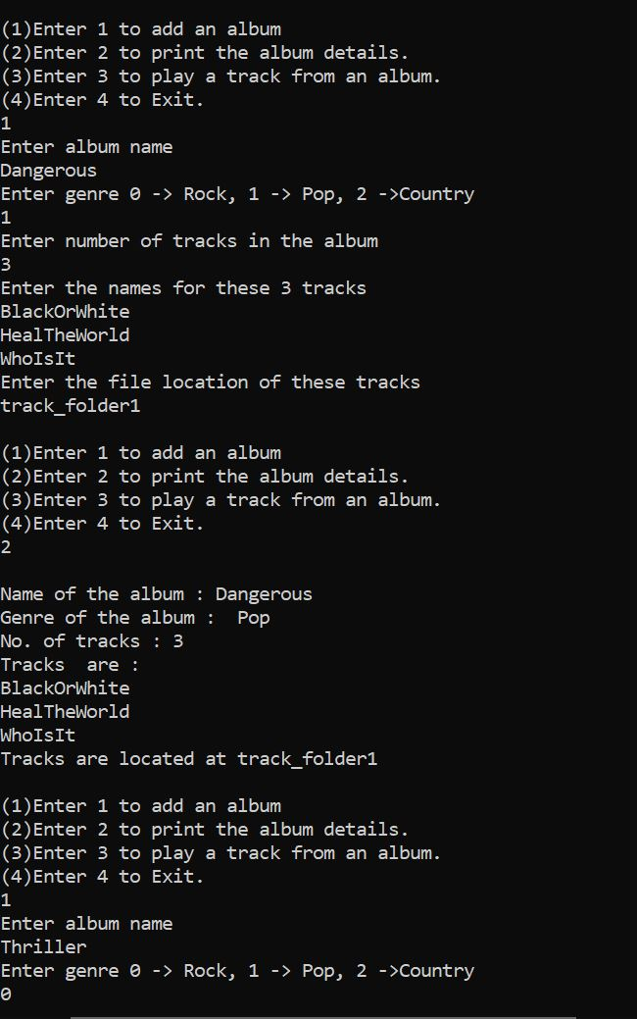
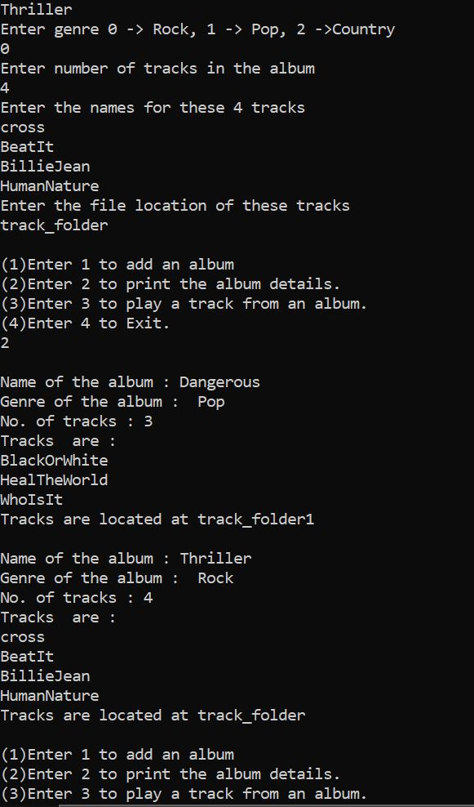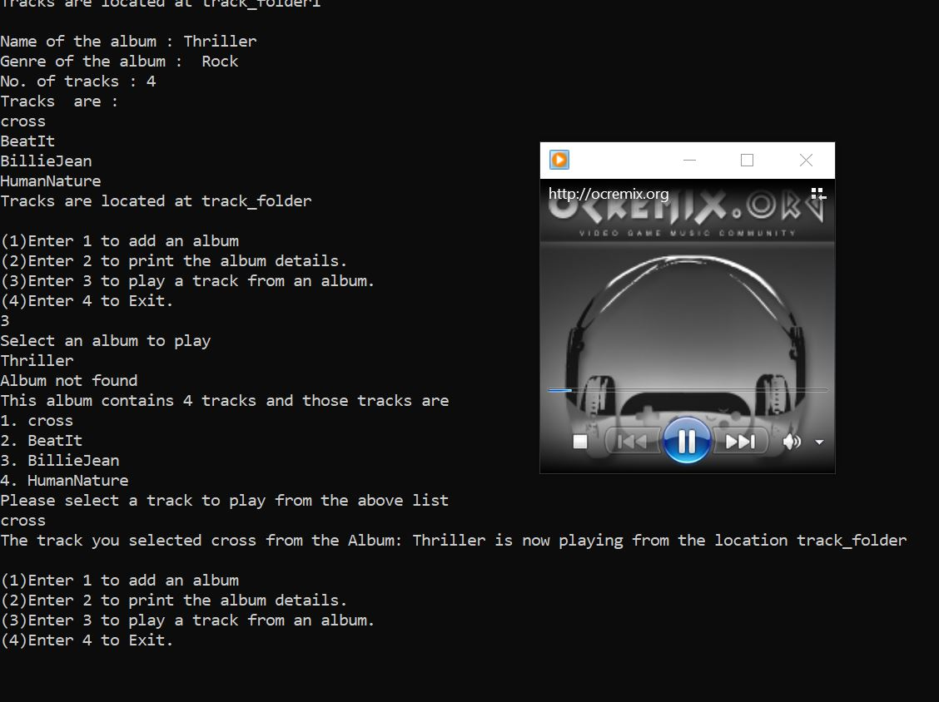

Task 10.2

Program description
This program uses linked list to manually enter data into the nodes. It then displays the nodes in the order they were entered.

Source Code
- #include <iostream>
- #include <string>

- using namespace std;

- struct studentname {
- char letter;
- struct studentname *next;
- };
- typedef struct studentname STUDENTName;
- typedef STUDENTName *STUDENTNamePtr;
- //self referential structure

- int main() {

- STUDENTName *hptr;
- STUDENTName *cptr;
- STUDENTName *nptr;

- hptr = NULL; //intialized to null

- hptr = cptr = nptr;
- nptr = new STUDENTName;
- nptr -> letter = 'A';
- cout << "Linked List\n";
- cout << nptr-> letter << "--> "; //printing nptr
- nptr->next = NULL; //nptr to next =null

- nptr = new STUDENTName;
- nptr -> letter = 'G';
- cout << nptr-> letter << "--> "; //printing nptr
- nptr->next = NULL; //nptr to next =null

- nptr = new STUDENTName;
- nptr -> letter = 'L';
- cout << nptr-> letter << "--> "; //printing nptr
- nptr->next = NULL; //nptr to next =null

- nptr = new STUDENTName;
- nptr -> letter = 'O';
- cout << nptr -> letter << "--> "; //printing nptr
- nptr->next = NULL; //nptr to next =null

- nptr = new STUDENTName;
- nptr -> letter = 'Y';
- cout << nptr-> letter << "\n"; //printing nptr
- nptr->next = NULL; //nptr to next =null
- cptr = hptr;
- return 0;
- }

Screenshots showing working program
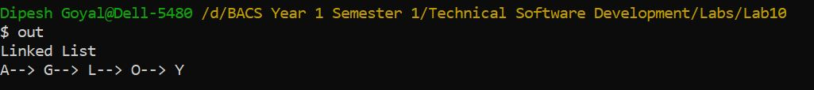

Task 10.3

Program description

This program uses linked lists. The program is getting an array of 10 random integers. After sorting them using bubble sort it then inserts it into the linked list. Once the data is stored in the linked list, it is then displayed. After displaying the data, the average of the data in linked list is displayed through a function.

Source Code
#include <iostream>
#include <ctime>

using namespace std;

struct Node
{
int data;
Node *next;
};

Node *hptr = NULL;

//function protypes
void insert(int new_data);
void display();
void BubbleSort(int array[]);
double node_average(struct Node *head);

int main()
{

int array[10];
srand(time(NULL));

for (int i = 0; i < 10; i++) // generating random numbers
{
array[i] = rand() % 50 + 1; // storing random numbers in array
}

BubbleSort(array); //passing array to get sorted
for (int i = 0; i < 10; i++)
{
insert(array[i]); // passing in function to read in linked list
}

cout << "The linked list is: ";
display(); // displaying linked list
return 0;
}

void insert(int data) // insert to linked list
{
Node *nptr = (Node *)malloc(sizeof(Node));
nptr->data = data;
nptr->next = hptr;
hptr = nptr;
}
void display() // displaying lunked list
{
struct Node* head = NULL;
Node *ptr;
ptr = hptr;
while (ptr != NULL) // till ptr is empty
{
cout << ptr->data << " ";
ptr = ptr->next;
}
cout << "\nAverage of nodes = " << node_average(hptr); // average
}

void BubbleSort(int array[]) //bubble sort
{
int i, j, temp;
for (i = 0; i < (10 - 1); ++i) //outter loop
{
for (j = 0; j < 10 - 1 - i; ++j) //inner loop
{
if (array[j] < array[j + 1])
{
temp = array[j + 1];
array[j + 1] = array[j];
array[j] = temp;
}
}
}
}

double node_average(struct Node *head)
{
if (!head) // if head is null
return -1;
int count = 0;
int sum = 0;
double avg = 0.0;

struct Node *cptr = head;
while (cptr != NULL)
{
count++;
sum += cptr->data;
cptr = cptr->next;
}
// calculate average
avg = (double)sum / count;
return avg;
}

Screenshots showing working program
